**Week 6-1.React JS-HOL**

**Name-Adi Jain**

**Superset ID- 6390400**

**Hands on**

Create a new React Application with the name “myfirstreact”, Run the application to print “welcome to the first session of React” as heading of that page.

**Code**

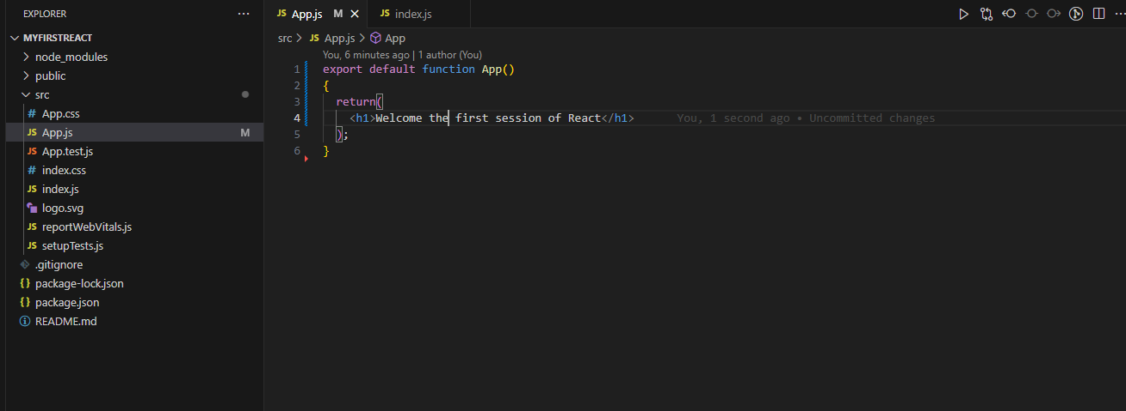

**========================================================**

**Output**



